Bootham School
Tutor Programme
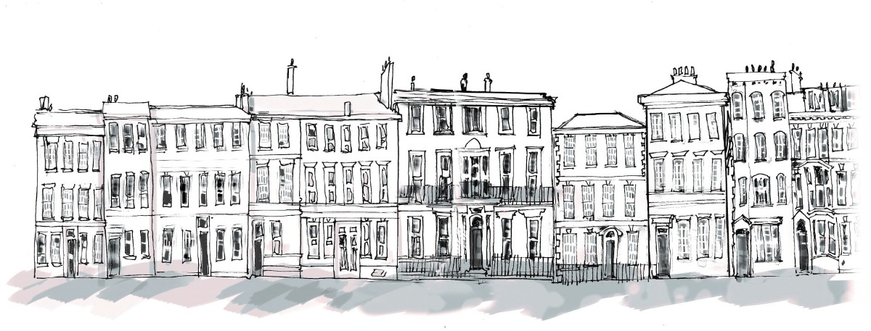

Lower Schoolroom

New Beginnings

Name:

Tutor:

What is the New Beginnings booklet?

New Beginnings is a series of tasks for you to complete which will help you to make a smooth transition from your junior/primary school into Lower Schoolroom at Bootham. The information that you collect in your booklet will help your us to give you guidance and support you on your journey through Lower Schoolroom. The booklet will help you to do the following things:

- reflect on yourself

- look at your achievements

- decide your strengths and weaknesses

- consider your skills and qualities

- think about the things that you are looking forward to

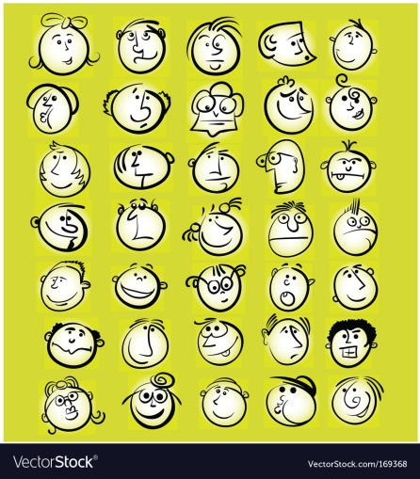
Which of the faces on the cartoon represents how you are feeling now about starting at Bootham? Circle it, write the emotion that you think it is showing and explain why you might be feeling this way.

What have I achieved so far?

Think about your achievements as you start secondary school

Achievements in Primary School…

Evidence…

Achievements outside school…

Evidence…

List 3 things that have helped your transition (move) from primary to secondary school…

1.

2.

3.

Can you suggest something that Bootham could do to improve the transition for future Lsch students (to help new students to feel less nervous and more like they know about the school?

A New Start

Take some time to think carefully about what you have gained during your time at primary school and what you are looking forward to in secondary school.

In Primary School | At Bootham Senior
I was good at… | I am looking forward to…
My favourite subject was…  because… | I am apprehensive about…
I learned to… | I am excited about…
My proudest moment was… | Am going to…
I took part in… | I will join…
One difficulty I overcame was… | I plan to…

Bootham Question Brain Dump!!!
Use the space below to write down things you want to know about Bootham and how the school works

Who Can Help Me?
With the help of your tutor complete the table below:

Member of Staff | Name | Think of one way that this person might be able to help you/ one thing they could help you with
Subject teachers

Tutor

Health Centre

Receptionist
Head Teacher

Head of Year

JCR Supervisor

Deputy Head

Safeguarding Lead

Think of another person at Bootham who could help you.

Name:

Job:

What Is Bootham Like?
Bootham is a Quaker School and so we try to live by the Quaker values (SPICES) in this school. Below is a list of those values. Discuss what you think these things mean and then make a mindmap of what we could do in the tutor group or the school to live out those values (for example “integrity” might involve admitting when we get things wrong. “Stewardship” might mean that we recycle our rubbish after bars.)

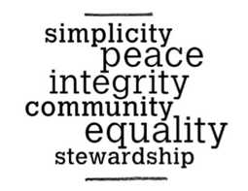

Schoolrooms Standards

Your Attitude
• Act kindly and respectfully towards all other members of the community
• Be open and honest in all things
• Be punctual and fulfil all your commitments
• Always be prepared to consider that you may be mistaken, and learn from your mistakes
• Collaborate positively and generously with others
• Use mobile technology positively and within school guidelines
• Develop a healthy balance between hard work and recreation

Your Learning
• Be on time, properly equipped and prepared for all lessons and activities
• Ensure that your behaviour in class allows effective teaching and learning
• Engage actively in lessons and strive to do your best
• Complete your work to the best of your ability and meet all deadlines
• Revise for all tests and exams, and always make sure you learn lessons from them

Your Community
• Make your tutor and year groups welcoming, positive and inclusive of all
• Meet the obligations that come with being a member of the community
• Treat all other members of the community fairly and aim to resolve any conflict peacefully
• Stand up for those who might be mistreated by others
• Speak out respectfully when you notice things in school that need challenging or changing
• Look after social spaces and be especially sure to behave well in them

In each standards section above, identify (highlight, underline etc) one or two expectations that you think you will find easiest to uphold and one or two expectations that you think you might find difficult. Below choose the three that you think you will find the hardest and give an idea of how you might work on that.

Expectation | Why Hard? | What to do?
Meet all deadlines | I get confused about when things are due in and then I leave work late | Check with teachers when work is due and write the due date in my planner. Try to do work on the night it is set. If I get behind, start with the ones that are due soonest
What Influences Me?

During your life you will make many important choices and these will often be influenced by other people or things around you. It is important to be aware of the things that influence you and to understand that it is good to have your own opinions.

Look at the following list and think about what things or people influence you most when you are making choices about your future.

Put the list in order 1-10

1= least influence

10 = most influence

- Yourself

- Family

- Friends

- Teachers

- Newspapers and magazines

- Celebrities

- Websites and Social Media

- TV Shows

- Tutor

- Youth worker

Compare your order to someone else in your group. Discuss differences and similarities in your order.

What Influences Me?

Whose opinion do you value most and why?

Can you think of any problems with being influenced by others?

Who inspires you and why?

Bootham School

Lower Schoolroom

Future Plans

Name:

Tutor:

What does success look like?

We all have different opinions on what it means to be successful. We can all be influenced by what we understand to be a successful career.

Look at the careers below and rate them on a scale from 1 to 8 with 1 being most successful in your opinion.

Nurse

Charity Fundraiser

Plumber

Teacher

Lawyer

Environmental Activist

Sportsperson

Builder

Explain why you thought the jobs that you ranked as 1 and 2 are the most successful in your opinion…

Find someone in the group who put a different job as number 1 (most successful) this will be someone who has a different opinion to you. Talk to them and explain below why they made their decision…

What else does it mean to be successful? What else would you want to have in your life? (Think – family, friends, money, housing, making a difference etc)

What am I like?
Check your personal qualities. Circle your scores and discuss any “not sures” with someone else in the group who knows you to help you to decide.

0 = not like me 1 = quite like me 2 = very like me ? = not sure

Personal Quality | Score
team player | 0 | 1 | 2 | ?
sensitive | 0 | 1 | 2 | ?
friendly | 0 | 1 | 2 | ?
energetic | 0 | 1 | 2 | ?
organised | 0 | 1 | 2 | ?
adventurous | 0 | 1 | 2 | ?
easy going | 0 | 1 | 2 | ?
thoughtful | 0 | 1 | 2 | ?
good sense of humour | 0 | 1 | 2 | ?
honest | 0 | 1 | 2 | ?
conscientious | 0 | 1 | 2 | ?
responsible | 0 | 1 | 2 | ?
resilient | 0 | 1 | 2 | ?
ambitious | 0 | 1 | 2 | ?
patient | 0 | 1 | 2 | ?
polite | 0 | 1 | 2 | ?
considerate | 0 | 1 | 2 | ?
helpful | 0 | 1 | 2 | ?
adaptable | 0 | 1 | 2 | ?
enthusiastic | 0 | 1 | 2 | ?
creative | 0 | 1 | 2 | ?
determined | 0 | 1 | 2 | ?
leader | 0 | 1 | 2 | ?

Pick out the 2 qualities that you show most often in school…

Pick out the 2 qualities that you show most often outside school…

What’s My Evidence?

When you are older and you come apply for jobs, it can be helpful to have examples of how you have shown the personal qualities that you have.

Think of 3 personal qualities and describe how you have demonstrated them recently.

Personal Quality | Evidence – example of how you have used this quality
E.g. independent | I used the library after school to carry out some research for my History homework

My Skills

To be successful in school, life and your career you will need to have certain skills.

Circle any skills that you think you have already developed.

caring for people working in a team

communicating well

problem solving
working with money

literacy skills playing a sport

drawing and painting

playing a musical instrument

working on your own

using your imagination
good at practical tasks being creative
using maths

learning from mistakes

using a computer
speaking another language

Make a list of any additional skills that might be important…

Employability Skills

These are the skills that future employers will be looking for:

- Working well with others – what do you think this means?
- Communicating with others
- Using maths
- Teamwork
- Problem solving
- Creativity
- Using ICT
- Being well organised
- Leadership skills
- Being able to work alone (independent)
- Being actively involved in your community

What’s My Evidence?

What are your strongest skills and what is your evidence?
SKILL | EVIDENCE  (How have I shown this skill?)
1

2

3

4

5

6

Are there any of these skills that you would like to develop? How could you start to do that?

All About Me

Imagine that you are being interviewed for a Saturday job. Complete the form below and summarise the important information about yourself.

My name is……………………………………...

I am……………...years old

I am good at…

At school I enjoy…

I my spare time I…

In the future I would like to…

My strongest personal qualities are…

My best skills are….

My Skills Research

Quiz!!! Which animal are you?
Use the website https://animalme.myworldofwork.co.uk/ to complete the following tasks;

- Complete the Quiz

What type of animal are you?

Give two strengths of your animal.

1

2

Name 3 areas of work that your animal is well suited to

1

2

3

Research one of the areas of work in more detail and find 10 key facts about working in this career area. This could include what qualifications you need, how it helps to make the world better, how much it pays, what they do on a daily basis etc.

10 Facts About…

Name of Career Area:

1.

2.

3.

4.

5.

6.

7.

8.

9.

10.

Are You Creative?

To be creative you need to…

- Use your imagination
- Look for new possibilities
- Find new ways of doing things

Take a food product and use your creativity to show how it can be used to develop new product ideas
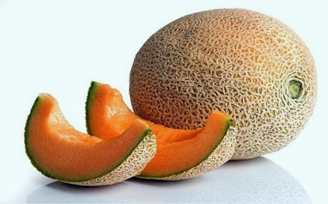
E.g. Melon

- Fruit salad
- Melon balls
- Melon sorbet
- Melon yoghurt
- Melon and banana smoothie

My Product Ideas

My Food Product

Can you carry out the same creative process with an item or product that is not a food? Draw a spider diagram below to show your ideas…

Think of 2 reasons why employers are keen to recruit people with creative skills. What other skills might employers be looking for?

Setting Targets

A target is something to aim for. Targets should be realistic but not too easy to achieve, they should challenge you.

Look at the list of targets below circle them if you think they are long term targets and underline them if you think they are short term targets.

To be able to drive a car

To have 100% attendance this year

To go to university to study law

To get good exam results at the end of Year 11

To own my own house

To write my homework in my planner every day

To join a sports club this term

To have a part time job

To carry out a work experience in an office

To save money to buy tickets for a concert next month

My Targets

Personal Target

Short term
Long term
Academic Target

Short term

Long term

Career Related Target

Short term

Long term

