COLLEGE UCAS HANDBOOK

2021/2022

Timetable for UCAS process
Key dates
Dates are subject to change. Please keep an eye on relevant websites and emails.
18 May 2021 | UCAS opens for students going to university in Autumn 2022. You can start your application from this date. Time will be spent in C1 Specials guiding you through the process
May – 1 October 2021 | Medicine applicants register for UCAT (University Clinical Aptitude test). Students do this directly via www.UCAT.ac.uk. There is a fee for this.
1 August 2021 | Registration opens for LNAT (Law Admissions test). Pupils do this directly via www.LNAT.ac.uk
7 September 2021 | Applications to UCAS can be submitted from September
2-6 September 2021 | Register for university admissions tests including BMAT (BioMedical Admissions Test) and TMUA (Test of Mathematics) (not LNAT or UCAT). Students should register with Bootham Exams Manager too.
6 September 2021 TBC | INDUCTION DAY for College Two Students working with their tutor on the UCAS form and Personal Statement. Students must bring a good draft of the Personal Statement with them and the UCAS application form completed, as stated by HS in Specials sessions.
25 September 2021 | Internal Bootham deadline for Oxbridge/Medicine/Dentistry/Veterinary applicants
1 October 2021 | UCAS deadline for submission to music conservatories
15 October 2021 | UCAS Deadline for Oxford and Cambridge and Medicine, Dentistry and Veterinary Science programmes
1 December 2021 | Bootham deadline for all other UCAS applications
15 January 2022 | Equal consideration deadline for applications for most undergraduate courses. If an application is received by this date, the university must consider it.
Jan – March 2022 | Art Foundation courses require direct applications (not through UCAS) and will have different dates for submission. Please check their websites carefully. Ask HS or David Swales for advice on the application process.
February 2022 | UCAS Extra opens. This is for applicants who do not have any offers once they have heard back from all their choices, or for applicants who decline all offers. It closes in early July.
May/June 2022 | Students who have applied in good time are normally given a date in May/June by which they have to choose their firm choice and their insurance choice. The date might vary between students depending on when they applied and when they hear from the final university to give them a decision.
July 2022 | Clearing opens. Clearing is how unis and fill any places they still have on their courses.  From July until October you can apply for a course using Clearing if you’re not already holding an offer from a university and the course still has places.
August 2022 | Results day. Universities start to confirm places once exam results are known.

Completing the application timescale
Summer Term
- Explore the resources on unifrog
- Course searches can also be done on the UCAS website using the ‘Search for Courses’ facility
- Check admissions requirements of courses you are interested in, and how the course is taught and assessed
- Attend 5 May UCAS Discover Day
- Obtain prospectuses, look at individual university websites to research course content and standard and specific entry requirements
- Talk to parents, friends and your Tutor about your research
- Visit Universities (This may be virtual open days or, if things open up as we move into Summer and early Autumn there may be physical Open Days)
- Parents should email a list of open day visits you plan to make to your tutor (max of 4) and attendance@boothamschool.com

Personal Statement
- You must complete a draft of your personal statement over the summer holidays
- Using Unifrog, gather all ideas and materials to be used when writing your statement
- Attend Specials on personal statement writing and have written the first two sections by the end of term
- Research gap year plans if you intend to take one
- Oxbridge/Medicine/Veterinary Medicine personal statement must be ready for initial review by end of summer term
Summer Holidays 2021
- Complete the Personal Details, Education and Employment section of UCAS form, if not already completed in summer term
- Continue your research, visits etc., on courses and university choices
- Complete MOOCs, additional reading, TED talks, podcasts, webinars, seminars etc. You really need to demonstrate your super curricular knowledge and commitment.
- Continue working on your draft personal statements so that it’s ready for review when you return in September
- Review your course and university choices

Autumn Term 2021
All College Two students to be in school on 6 September (TBC) to work on their applications 9am – 1pm with their tutor. You need to bring a laptop and have a good draft of your personal statement. If you are applying to courses with an early deadline, your personal statement should
- Ensure you have registered for any required admissions test
- Remember LNAT and UCAT are not organised through school
- Seek advice on your personal statement from your tutor
- Liaise with Harriet Metcalfe (Careers) if you require mock interview practice
The UCAS deadlines for Oxbridge/Medicine/Veterinary Medicine is October 15th. Bootham School’s internal deadline is 25 September as it takes time to check your form and add your school reference and predicted grades.
Similarly the UCAS deadline for all applications is January 15th but we require all forms by December 1st 2021 as we do not submit any forms to UCAS after the Christmas holiday.
Choosing
Make sure you check the GCSE and A level grade and subject requirements of your chosen courses. Some specify certain grades, in particular for English and Maths GCSE. Others might specify a Modern Foreign Language at GCSE. If you are applying to Oxbridge or Cambridge then your chosen college may have specific requirements.
If you are applying to a course with a Foundation year then check carefully the entrance requirements. Sometimes these are only open to students who meet certain criteria.
Check the small print of all your chosen courses to make sure you’re applying to courses you have a good chance of receiving an offer for. Some universities state that if you apply for particular courses then you can’t apply for certain other courses so be aware of this.
The UCAS application process is changing from May 2021 for those students going to university in 2022. This guide is correct as of 6 May 2021 but there may be some small changes we are not yet aware of. If this guide doesn’t seem to follow the UCAS website then please let Harriet know and updates can be made.

UCAS Hub
UCAS Hub is now the one place to register and sign in. You can use it to help you research and narrow down your options. You can save your research and pick up where you left off. You can use it to chat to current students, explore subject areas and subject areas and search for courses. You can use filters (e.g. entry requirements, location) to narrow down your course search. You can also access UCAS Hub live events.
It opens in May.
How to register
- Go to ucas.com/hub to register for 2022 entry and click the get started button.
- Click on register
- Enter your details, tick the box and then click next
- A code will be send to your chosen email address
- Enter this code and then follow the steps including year of study (2022 unless you’re taking a Gap year and level of study which is undergraduate)
Once logged on, from the Hub homepage you can start your application from 18 May. The Hub homepage looks like this:
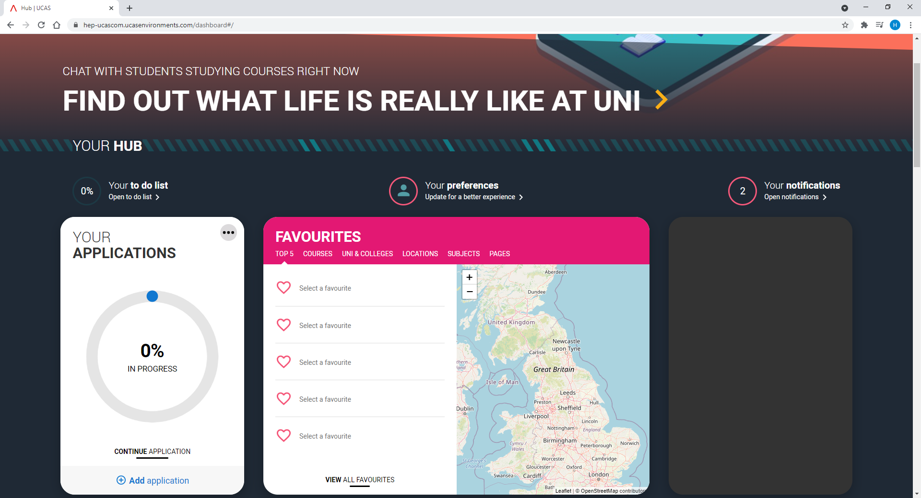
You need to think of the UCAS form as a job application. You are trying to convince an Admissions Tutor that you are the right person for their course.
You will complete your application form on line. The forms looks like this and is made up of the following sections: 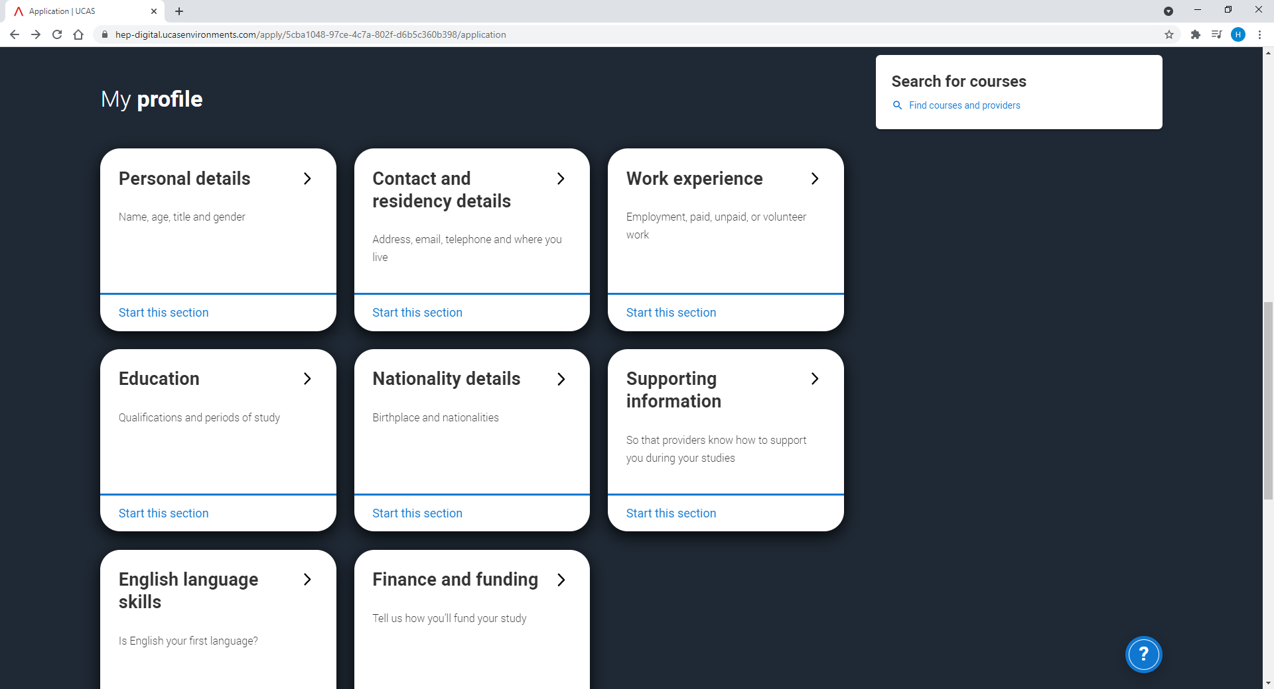

- Personal details
- Contact and residency details
- Work experience
- Education (secondary schools you have attended and qualifications taken and yet to be taken, i.e. your A levels)
- Nationality details
- Supporting information (which is about where you may have lived and also disability information)
- English language skills
- Finance and funding
- Choices
- Personal Statement
- References and predicted grades – completed by your Tutor
You mark sections as complete once you are happy they are correct.
REGISTRATION will be in the College Specials session May 18 at 4.15-5.15pm
Make a note of your password and username – Bootham does not have access to these. If you lose this information you will need to contact UCAS

There are various links and videos on the UCAS site which explains exactly how to fill in the form - https://www.ucas.com/undergraduate/applying-university/filling-your-ucas-undergraduate-application
When you register you provide all your personal details including first names, surname, date of birth, address, telephone numbers and email. You must complete everything that is marked with an *. You must check that information is correct. Errors are common with email addresses, dates of birth, phone numbers, exam grades and boards.
If you plan to go straight to University in October 2022 then you can use your Bootham email if you want to. If you intend to defer your entry because you are going to take a gap year then use your personal email (make sure it is sensible.)
You need to put that you are applying from a school, college or centre. If you click yes to this it will ask you to enter a buzzword to link your application to Bootham. This gives us permissions to view and track your application and enter your reference and to send the application to UCAS once it has been finalised and checked.
Common questions:
- Q - How are you applying? A- through my school/college
- Q – What’s the Buzzword? A- enter the Bootham buzzword – Bootham22
- Q – What do I enter for Tutor Group? A – Click on the drop down menu with names of tutors and pick yours.

You will see your Personal ID in the top corner of your homepage (10 digits) – make a note of this. We advise taking a photo on your phone.

Personal Details
Some of this section will be automatically filled in with the details you entered during registration. Check this information and fill in the other questions.
- Your name should match the name that is used to register you for exams
- Previous surname at 16th birthday (only fill out if different from your current one)
- Date of birth
- Gender
Contact details
- Telephone number
- Address
- Nominee access if you want someone else to be able to act or speak on your behalf e.g. a parent. If you are likely to be away during the application process, including results day you may want someone to act for you and discuss your application with UCAS if necessary and make decisions on your behalf.
- Residency details

Work experience
- This is paid work. Unpaid work or volunteering should be included in your personal statement
- Names and addresses of recent employers
- If you have not had any paid work experience, you can leave this section blank, but you will need to mark it as complete.
Education
- If you have a Unique learner number (ULN) then enter this
- Highest level of qualification you expect to have before you start your course is below honours degree
- Add all secondary schools you have attended
- The exam centre number should automatically come up
- Add start date and end date
- For a start date in Lower Schoolrooms put September 2015
- For a start date in Lower Seniors put September 2018
- For a start date in College 1 put September 2020
- For your finish date at Bootham please put August 2022.
- Type of study is full time
- When you have added a school, you then need to add qualifications gained at that school. You need to list the schools you have attended since the age of 11 and all the qualifications you have taken or are taking including A levels, GCSEs, IGCSEs, Music Qualifications, LAMDA.
- Add your A levels which you have yet to sit. The official title of these is GCE Advanced level
- You should enter achieved qualifications with the attainment level awarded and pending qualifications should be added without attainment listed. Qualifications you may need to enter include:
  - GCSE
  - IGCSE
  - IGCSE Double Award (Science)
  - EPQ Extended Project (level 3) (grades are Pending)
  - GCE Advanced Level subject you will be taking in College II (grades are Pending)

- Answer the question ‘did you/will you receive qualifications at this centre’. Answer yes otherwise you will be unable to add any qualifications to this centre.
- You will need to know the qualification type, subject or course title, qualification date, the awarding organisation and the grade. If you are currently studying towards a qualification you need to select pending for their grade. This shows you have not yet achieved the qualification and will allow referees attached to their application to supply predicted grades. A student is not able to add an achieved grade for qualifications that have a qualification date in the future. Make sure you list you check that you have listed your A levels separately from GCSEs and that you have included all subjects.
- Use the search facility for other qualifications such as Music Grades, LAMDA.
Nationality details
- Country of birth
- Nationality
Supporting information
- If you’ve ever worked or lived in the EU
- If you have a parent who is an EU national
- Disability information. This is so universities can offer you appropriate support and is not part of their decision as to whether they offer you a place.
English language skills
- Is English your first language
- If not, you can enter TOEFL and IELTS numbers
Finance and funding
- What will be your main source of funding? For most pupils this will be UK, Chl, IoM or EU student finance services
- If you enter this then for student support arrangements use the drop down option to find the menu of UK Local Authorities and click on your Local Authority
- This is not part of your student finance application. You need to apply separately for this.
- International students are likely to need to enter Private Finance
Personal statement
More information on this at the end.
Choices
This is where you list your 5 choices of universities and colleges. Make sure you have thoroughly researched your choices, in particular entry requirements, subjects and grades for both A level and GCSE. There are drop down menus to help you. For each choice you need the following:
- Institution
- Course
- Location
- Start date – 2022 if you are to start in the current year, 2023 if having a gap year
- Further details
- Point of entry (normally year 1)
- Live at home while studying?

You must check all this information as Bootham will not check you have entered the correct course and institution codes

You can apply for five courses. If you are applying for Medicine, Veterinary Medicine and Dentistry you have a maximum of four choices. You can use your remaining choice for another subject such as Biological Sciences.
You may only apply for one course at either University of Cambridge or University of Oxford.
It does not matter what order you enter your courses in. You do not rank your choices. They will be arranged once your form is finished in alphabetical order. Universities do not know who else you have applied for until you have made your final decisions.
Check all the details in this section and when you are sure they are correct and completed then click on ‘finished’.
Additional notes on Choices:
- It is your responsibility to check on any Admissions Test requirements and to register. (check with HS and Harriet).
- If you enter a course into UCAS Apply which requires you to provide a portfolio, audition, interview or essay, a message will appear. You will get an invitation on UCAS Track and be able to accept or decline it online.
- For certain courses at University of Cambridge or University of Oxford you may be asked to submit written work in support of your application. It is your responsibility to make sure work is submitted by the required deadline.
- For certain health courses including Medicine, Dentistry, Nursing, Midwifery, UK health authorities recommend you should be immunised against Hepatitis B before you start your course. They may also ask you to have blood tests to show your immunity to certain illnesses – e.g., varicella. You must check the requirements for your chosen institutions.
- You may also have to complete a medical questionnaire and/or a DBS check and this could be a formal condition of your offer. You must do this and submit on time or you could end up forfeiting your place on a degree programme.
- If you are applying for multiple courses at the same university, check that they accept this. Check on the course webpage and also check the Admissions webpage. If in doubt, please speak to Harriet who can check. Some universities don’t accept applications for two courses which are both highly competitive, or may not accept applications for two similar courses.

We will give you a separate list of examination boards and course titles for subjects studied at Bootham. For students new to Bootham for College we will provide you with the information that we have but you should also check your own records.

Personal Statement
This is your chance to say why you’d like to study a particular course or subject, and what skills and experience you possess that show your passion for your chosen field. You’re telling Admissions staff why you’re suitable to study at their university or college. You need to demonstrate your interest in the course.
It’s important to remember you can only write one personal statement – it’s the same for each course you apply for. So, avoid mentioning any universities or colleges by name.
If you’ve chosen similar subjects, talk about the subject in general, and try not to mention courses titles. If you’ve chosen a variety of subjects, write about common themes and see how you can make links between your subject areas.
The first part of completing your personal statement is the research phase.
This includes:
- Attending open days or other events held by UCAS or by universities
- Work experience (on line if required), volunteering or free online courses to expand your subject knowledge. This could be MOOCs.
- Talks, documentaries or podcasts
- Additional reading
Look at your chosen course descriptions and identify the qualities, skills, and experience they require.
- You need to detail why you’re applying – include your ambitions and what interests you about the subject.
- Why are you excited about the course and how can you evidence this? Think about your work experience, super curricular learning etc.
- Think about what makes you suitable – this could be relevant experience, skills, or achievements you’ve gained from education, work, or other activities. What makes you exciting, interesting or makes you stand out?
- Include any clubs or societies you belong to – sporting, creative, or musical. Extra curricular evidence such as this should be a maximum of 20% of your application form. If you’re applying to Oxbridge then it should be no more than 10% of your total personal statement.
- Mention any relevant employment, work experience or volunteering you’ve done
- If you’ve developed skills through Duke of Edinburgh or other schemes for young people, include this
- If you took part in a higher education taster course, placement, or summer school, or something similar, include it.

Once you have done the research, you can write a first draft. You will then need to review this draft and redraft a number of times to get to a stage where you have something suitable to send off.
There is no inbuilt spelling and grammar check within the form. You have 4000 characters (not words so this includes spaces) or 47 lines of text, whichever comes first.
If you are applying through UCAS Conservatoires find out how to write a UCAS Conservatoires personal statement by looking at advice on the UCAS website.
Remember that your personal statement should be unique, so there’s no definite format for you to follow. Here are some guidelines for you to follow, but remember your personal statement needs to be ‘personal’. At Bootham we use Unifrog to allow you to write and gain feedback on your statement and once you and your tutor are happy with it you cut and paste into your UCAS application.
- Punchy opening paragraph. Show your enthusiasm and understanding for your subject area.
- Middle/main body -This should be packed with evidence including work experience, outside reading, and demonstrations of your skills.
- End – how will you fit into uni life, what makes you unique? Or you might want to talk about the future and what you plan to do.
- Write in an enthusiastic, concise, and natural style – don’t use overly complicated language
- Try to stand out, but avoid using clichés, humour or quotes.
- Structure your info to reflect the skills and qualities your chosen courses value most – use the course descriptions to help you.
- Check the character and line limit – remember you only have 4,000 characters and 47 lines. Some word processors get different values if they don’t count tabs and paragraph spacing as individual characters.
- Proofread aloud, and get your tutors and family to check. Then redraft it until you’re happy with it, and the spelling, punctuation, and grammar are correct.
- Keep it focussed and relevant.
- Make sure you click save regularly, and preview it before you complete the section.
- Keep going. It will take many drafts to get it right.
We recommend you write your personal statement in Microsoft Word first, then copy and paste it into your online application once you're happy with it. Make sure you save it regularly, as it times out after 35 minutes of inactivity.
How to write a personal statement
- https://www.ucas.com/advisers/which-for-teachers/help-your-students-get-into-uni/how-to-help-your-students-write-their-personal-statement-tips-activities-and-resources
- https://www.ucas.com/undergraduate/applying-university/writing-personal-statement/how-write-personal-statement

How to start and end
- https://www.ucas.com/undergraduate/applying-university/writing-personal-statement/personal-statement-the-killer-opening
- https://www.ucas.com/undergraduate/applying-university/writing-personal-statement/how-to-end-your-personal-statement

Personal statements talk
- https://www.ucas.com/connect/videos/hub-live-videos?v=/lets-talk-personal-statements&rl=1
Using Duke of Edinburgh
- https://www.dofe.org/thelatest/ucas-advice/
Using your hobbies
- https://www.ucas.com/undergraduate/applying-university/writing-personal-statement/hobbies-and-your-personal-statement
When you have completed all sections of the application you need to click on the ‘view all’ section. Here you can view all your application on one page to review and check the content. Mark the view all section as complete before you can submit. This isn’t’ submitting the form to UCAS, it’s submitting it to Bootham so we can finalise it and complete your reference. We then submit it on your behalf. There is a cost to apply but you do not pay directly. The school has an account with UCAS. Choose “Cheque to Centre” as payment option but you do not need to write a cheque. The cost is added to your school bill. It’s £22 for one choice and £26.50 for 2-5 choices.
Once you have submitted it to us, your tutor will upload your reference and tell Helen that the form is complete. There is a final check and then your application is sent off.
Track Progress
Once your form has been sent by the School you can track the progress of your application online. You will need your Personal ID number, Username and Password to use UCAS Track. Please ensure you tick the box to share information with your School.

