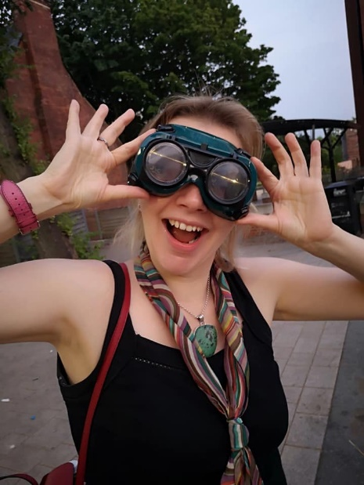
Congratulations on Choosing Psychology!

- https://drive.google.com/file/d/1dht_sumxC-TPZrjJF9oCN225bwxRcx5W/view
The taster talk from 29th June if you missed it!

Links to resources mentioned in the talk
- https://digest.bps.org.uk/ sign up and get research updates of interest in your inbox

- https://www.youtube.com/watch?v=PUO-vekv4lI My talk on Coping with Uncertainty for The York Festival of Ideas 2020

- https://www.youtube.com/watch?v=0sUcdpTGY5E My talk on Altered States of Consciousness for The York Festival of Ideas 2021

Below is the department open evening talk you may already have watched the live version if you are a Bootham Student

- Interested in studying at A-Level, then find out more here https://youtu.be/yav4c_XIgGo

- Electronic Textbook Login:

http://www.illuminate.digital/aqapsych1/
username: SBOOTHAM
password: student

