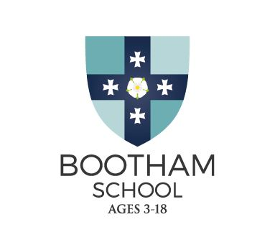

**Request for a Digital Portrait Photo**

We require a digital portrait photo of your son/daughter by the end of the summer term. This image will be uploaded to our database for the start of term and will also enable us to produce key cards for all students. A head and shoulders shot taken on a mobile phone is usually sufficient.

Here are a few guidelines to help you:

1. Please ensure the photos are:
   1. in colour;
   2. taken against a plain background  (white, cream or light grey);
   3. taken within the last month;
   4. clear and in focus;
   5. saved in a JPG format;
   6. at least 100KB in size;
2. The image of the student should be:
   1. a close-up - full head and shoulders;
   2. just of the student, with no other objects or people;
   3. facing forward and looking straight at the camera;
   4. without anything covering the face;
   5. in clear contrast to the background;
   6. without a head covering (unless it’s worn for religious or medical reasons);
   7. with eyes open, visible and free from reflection or glare from glasses;
   8. with your eyes not covered by sunglasses, tinted glasses, glasses frames or hair;
   9. without any ‘red eye’;
   10. without any shadows in the picture;

Here are some sample photos:  
  
   

**Please send your digital image to: Fiona.ward@boothamschool.com**