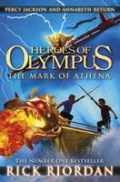
The phenomenally successful Rick Riordan is back with the next thrilling installment of the Heroes of Olympus series. Can Percy Jackson and the Half-blood Heroes succeed on their quest to find The Doors of Death or will the Greek Gods of chaos win their battle to stop them? Percy and his fellow demi-gods face the most important quest of all - the Prophecy of Seven

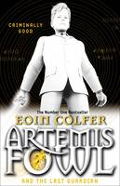
This is bestselling master storyteller Eoin Colfer, who set readers alight with his first title about Artemis Fowl, a young criminal mastermind who was more than a bit mixed up with the fairy world. Still working with the fairy world, Artemis is now older and wiser but still cleverer than everyone else around him. As ever, all his fans, will be delighted by what he does in what we're told is the final thrilling Artemis Fowl adventure. Let the misadventure begin - for the last time.

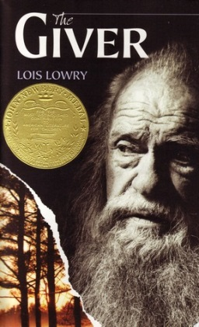
Jonas's world is perfect. Everything is under control. There is no war or fear or pain. There are no choices. Every person is assigned a role in the Community. When Jonas turns twelve, he is singled out to receive special training from The Giver. The Giver alone holds the memories of the true pain and pleasure of life. Now, it is time for Jonas to receive the truth. There is no turning back

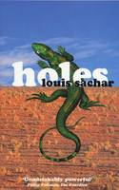
"Boys in jail – a great idea. The jail has no roof and they have to dig huge holes in the baking sun all day – it’s getting even better. I read Holes in hospital a few years ago. I wasn’t ill, and was only there for the day. I actually forgot I was in hospital, the book was so good. I had about ten pages left when a nurse told me I could go home. I was half-hoping she’d tell me I’d have to stay longer, so I could finish the book." Wholly original and brilliantly plotted, Holes is a funny and poignant story about surviving. When Stanley Yelnats is falsely accused of stealing a pair of trainers, he is sent off to Camp Green Lake which is not a camp, not green and not near a lake but a boys’ detention centre in the middle of the desert. Every day every boy has to dig a hole five foot deep and five foot across because, the Warden says, it’s good for them. How Stanley survives and proves that the Warden has a different and far more sinister motive for wanting so many holes to be dug unravels in unexpected and wholly satisfying ways.
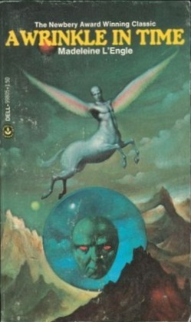
This is a story where the fate of the galaxy rests in the hands of a few geeky kids. I remember being enthralled, terrified, amazed and transported. What a teacher! What a book!" Also chosen by November 2011 Guest Editor Steve Cole: "A year before 'Doctor Who' first aired on our screens this lively and satisfying fantasy gave us Mrs Who, the original mysterious alien to travel the universe with a clutch of humans. She's one of three immortal entities (together with Mrs Which and Mrs Whatsit) embroiled in a long struggle against the evil Black Thing, a cosmic cloud of darkness. Three human children are recruited to join the battle, traversing the universe via wrinkles in space-time. Compelling and profound, the aliens and strange worlds they encounter still evoke awe and wonder in this reader."
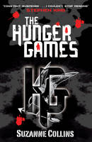
"I don't usually go for blockbuster dystopian stories - but this trilogy is imaginatively conceived and well written and a genuine page-turner. Sixteen year old Katniss takes part in a terrifying annual televised game where teenagers fight for their lives. In our current climate of reality television shows like The X-Factor and I'm a Celebrity, Get me out of Here, this starts to ring horribly true. It's often disturbing, but it certainly will hold the attention of even the most reluctant reader. It's about to be a much-hyped film, so should attract even more attention."

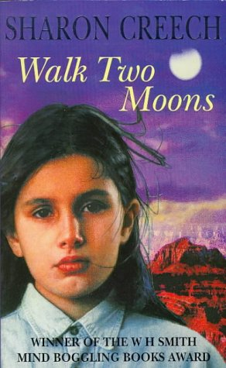
Salamanca Hiddle is travelling across the United States with her eccentric grandparents. On her journey, she tells the story of her friend Phoebe, a girl of wild imaginings. But beneath Sal's funny anecdotes is the deeper story of Sal's mother, who left home and never returned.

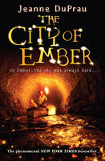
Many hundreds of years ago, the city of Ember was created by the Builders to contain everything needed for human survival. It worked - but now the storerooms are almost out of food, crops are blighted, corruption is spreading through the city and worst of all - the lights are failing. Soon Ember could be engulfed by darkness-But when two children, Lina and Doon, discover fragments of an ancient parchment, they begin to wonder if there could be a way out of Ember. Can they decipher the words from long ago and find a new future for everyone? Will the people of Ember listen to them?
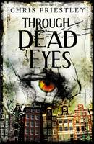
Alex joins his father on a business trip to Amsterdam. During the day he hangs out with the daughter of a family friend. They visit the usual sights but also coffee shops and flea markets off the beaten track. At one of these markets Alex spots an ancient-looking mask. Before he knows what he's doing he buys it. Later, in his hotel room, he feels compelled to put the mask on. Alex is sucked into a parallel Amsterdam, one from centuries before which begins to reveal the dark past of both the building he is staying in and the little girl who once lived there ...edging stealthily towards the terrible twist.

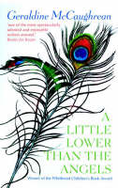
Gabriel has no idea what the future will hold when he runs away from his apprenticeship with the bad-tempered stonemason. But God Himself, in the shape of playmaster Garvey, has plans for him. He wants Gabriel for his angel...But will Gabriel's new life with the travelling players be any more secure? In a world of illusion, people are not always what they seem. Least of all Gabriel.Geraldine McCaughrean is considered an exceptional writer of our time. She has won the Carnegie Medal, the Guardian Children's Fiction Award, the Whitbread Award (twice) and the Blue Peter Book of the Year Award.
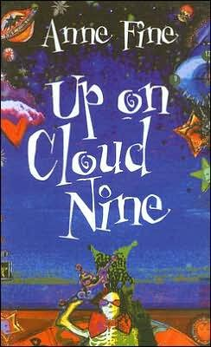
As Stolly lies wired up on the hospital bed his best friend touchingly charts the years of their friendship revealing both the strengths and the frailties of his friend. The result is an exceptionally sensitive novel about the complex emotions of adolescence.

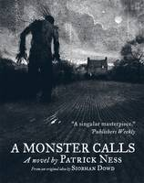
Prize-winning Patrick Ness displays brilliant new skills of sensitivity in this hauntingly touching story of how a boy deals with the looming threat of his mother’s death from cancer. Haunted by a monster in his dreams, denied much information by his family and treated as a weirdo by his class mates and a ‘special case’ by his teachers, Conor struggles to get to grips with the devastating emotions which threaten to overwhelm him.

How he finds the courage and strength to face the end when it happens is both utterly shattering and deeply satisfying. Costa Award winner Patrick Ness spins a tale from the final idea of much-loved Carnegie Medal winner Siobhan Dowd, whose premature death from cancer prevented her from writing it herself.

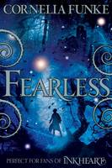
Best-selling Cornelia Funke has an exceptional gift for creating gloriously gothic otherworlds in which the unusual and seemingly impossible can – and does- happen. Part two of the Mirrrorworld series, Fearless follows Reckless and catches up with Jacob who desperately seeks a cure to overcome the curse imposed on him by the fairies. Jacob’s cure is such a dark magic that it must be deeply hidden; the search for it takes him where no one should tread. That would be dangerous enough but, worse still, someone else is desperate for the cure too. Luckily, Fox, a shape shifting girl is willing to help in the quest.

Stanley's dad hasn't been the same since his wife died and his eldest son went off to fight in the war. Now Stanley is either invisible to his dad or the object of one of his rages, and his only friend is his dad's prizewinning greyhound, Rocket. But one day Rocket escapes, and the result is a litter of non-thoroughbred puppies that Da says will all have to be drowned, even Stanley's favourite puppy, Solider. Stanley is so angry with his father that he runs away and enlists in the army to train as a messenger dog handler, and despite being far too young he's soon heading to France with a great Dane called Bones by his side. As the fighting escalates and Stanley experiences the horrors of war, he comes to realise that the loyalty of his dog is the one thing he can rely on. But his father hasn't given up on him, and extraordinary circumstances will bring them together once more ...

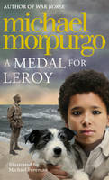

The best-selling author of War Horse tells a deeply moving story which recreates the terribly legacies of both the First and the Second World Wars in the deeply moving story about how a young boy discovers the truth about his family. Growing up just after World War Two, Michael lives alone with his mother. Together they visit two elderly women who looked after his father as a boy. What is the real story of his father? The truth is a story full of courage which Michael will hold close to himself for ever.

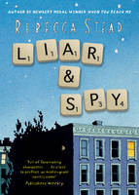
Award-winning Rebecca Steed tells a wonderfully touching story with great sensitivity within an exciting and dramatic adventure. Georges (his unusual name is part of his problem) has just moved to a new apartment block and he immediately gets caught up in a game with Safer, a boy who lives on another floor. Safer’s spying game seems fun and his family, sister Candy and brother Pigeon provide an interesting and supportive alternative home for Georges while things in his own family are out of kilter. But then Georges begins to have his doubts… Gradually everything he has been protecting himself from spins out of control and the reader discovers the sad truth he has been hiding himself from. A very special story that is not to be missed.

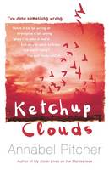
Award-winning author Annabel Pitcher’s new teen novel is a taut and dramatic adventure with a deep yearning at its heart. Ketchup Clouds vividly captures the terrifying roller coaster of emotion that envelopes Zoe when she gets caught in a tragic love triangle between two brothers. Zoe’s heart races for the mysterious Aaron but, despite his seeming keenness, he already has a girlfiend. And then there is younger brother Max, unattached and very keen on Zoe. How can Zoe manage her own feelings without hurting the boys especially when she’s also coping with puzzling dramas at home?
14 year +

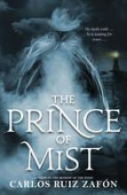

Utterly gripping, this is a deliciously haunting and chilling tale of dark magic and treachery which reaches out across time threatening all who cross its path.

A move to a house by the sea is designed to give Max and his sisters a safe home away from the dangers of the city in wartime. Although their new home comes with a tragic story of a young boy’s death, the family assume all sadness will have died with him. But, gradually, Max begins to uncover the secrets behind that death and in doing so, to find himself confronting the devilry of it head on. The superficial delights of the new seaside home and the friendships it brings are soon engulfed in a desperate and thrilling struggle for survival.

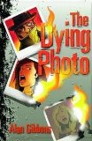

A brilliantly taut ghost story based on a blurb by a Year 6 boy from a Liverpool primary school who won a city-wide competition. A real page turner and a roller coaster ride that’s an excellent title for the reluctant, struggling or dyslexic reader. Alan Gibbons has won numerous awards including the Blue Peter award and has been shortlisted for the most prestigious book award, the Carnegie Medal.

A Dyslexia Friendly title.

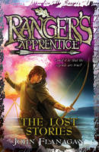
Ranger's Apprentice 11: The Lost Stories by John Flanagan
Will, there's something you should know. Something I should have told you long ago...There are stories about the Rangers that have never been heard before and it's time for you to hear them; stories about your parents and how you came to be an orphan; about how a Ranger's life was saved; and, about what happens next for you and your loyal friends. Are you ready to hear the truth?
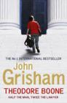
Half the man, twice the lawyer. In the small city of Strattenburg, there are many lawyers, and though he's only thirteen years old, Theo Boone thinks he's one of them. Theo knows every judge, policeman, court clerk - and a lot about the law. He dreams of being a great trial lawyer, of a life in the courtroom. But Theo finds himself in court much sooner than he expected. Because he knows so much - maybe too much - he is suddenly dragged into the middle of a sensational murder trial. A cold-blooded killer is about to go free, and only Theo knows the truth. The stakes are high, but Theo won't stop until justice is served. Brimming with the intrigue and suspense that made John Grisham a number one international bestseller and the undisputed master of the legal thriller, Theodore Boone will keep readers guessing and pages turning.
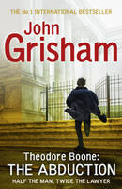
Theodore Boone is back in a new adventure, and the stakes are higher than ever. When his best friend, April, disappears from her bedroom in the middle of the night, no one, not even Theo Boone - who knows April better than anyone - has answers. As fear ripples through his small hometown and the police hit dead ends, it's up to Theo to use his legal knowledge and investigative skills to chase down the truth and save April. Filled with the page-turning suspense that made John Grisham a number one international bestseller and the undisputed master of the legal thriller, Theodore Boone's trials and triumphs will keep readers guessing until the very end.

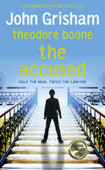
Theodore Boone is the thirteen year old who knows more about the law than most adult lawyers. He certainly never expected to be the victim of crime himself. But then his bike is vandalised, he's attacked while doing his homework and, worst of all, framed for a robbery. When stolen computer equipment turns up in Theo's school locker, the police start leaning on him hard. And he is the only suspect. What if he is found guilty? What about his dreams of becoming a lawyer? In a race against time, aided by his renegade uncle, Ike, Theo must find the real felon and reveal the true motivation behind the crimes of which he stands accused.

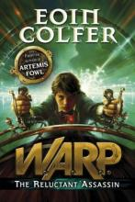
W.A.R.P.: The Reluctant Assassin by Eoin Colfer
The reluctant assassin is Riley, a Victorian boy who is suddenly plucked from his own time and whisked into the twenty-first century, accused of murder and on the run. Riley has been pulled into the FBI's covert W.A.R.P. operation (Witness Anonymous Relocation Program). He and young FBI Agent Chevie Savano are forced to flee terrifying assassin-for-hire Albert Garrick, who pursues Riley through time and will not stop until he has hunted him down. Barely staying one step ahead, Riley and Chevie must stay alive and stop Garrick returning to his own time with knowledge and power that could change the world forever.

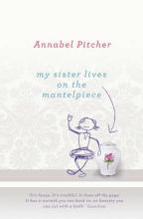
Heartbreaking and funny in equal measure, 10-year-old Jamie's direct and wide-eyed account of the emotional chaos he and his family live through following the death of his sister in a terrorist attack is poignant and warm-hearted. Beginning a new life in the Lake District with his older sister and his father, who mourns his daughter through alcohol and a wild rage against her killers, Jamie knows he should feel sadder than he does. The truth is, he can hardly remember his sister; and what is happening with his new school and new friends, especially Sunya, is more urgent – as is his yearning for his absent mother. Emotionally charged, this is a wonderfully touching story which never slips into worthiness.
14 years+

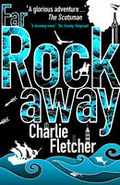
Best-selling Charlie Fletcher cleverly intertwines stories within stories in this dramatic and ambitious adventure. When Cat is slammed into by a fire truck crossing a road in central Manhattan, the blow to her head spins her into a world of make believe. Preoccupied before the crash by the lie she told her grandfather about having read a book that he gave her, Cat finds herself taking on daring deeds in the thrilling worlds of The Last of the Mohicans and Treasure Islands. As a reader of these books, Cat had felt herself as an outsider in a male dominated world but now she has the lead roles and the chance to show just what girls can do. The background of Cat and her grandfather’s life saving medical support after the crash makes a moving background to the whole.

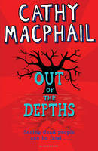
'I saw my teacher in the queue at the supermarket last Christmas. Miss Baxter. I was surprised to see her. She'd been dead for six months' In Out of The Depths, Cathy MacPhail introduces her latest character, Tyler Lawless, who has an unusual and sometimes scary gift. She is able to see dead people. And sometimes they speak to her, asking for her help. When Tyler moves to a new school she is hoping to make a fresh start. But that isn't easy when a boy who is supposed to be dead appears in your classroom, and statues in the school seem to come alive and point towards the place where the dead boy, Ben Kincaid, was murdered. Will Tyler be able to assist Ben with his pleas for help, or will she be dismissed as an attention-seeking teller of tall tales? A thrilling and spooky tale from the acclaimed Cathy MacPhail.
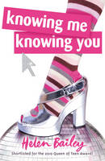
Chantelle 'Channy' Allen is just about enduring her slightly bored teenage existence - trying not to die of embarrassment every time her parents' Abba tribute band perform a cringing medley of hits in front of all her friends...But then Channy finds out something that turns her world upside down; something that makes perfect sense, but at the same time seems utterly ridiculous. Something that Channy is intent on investigating - despite the distraction of gorgeous French exchange student Antoine. Channy's about to learn a valuable life lesson: sometimes curiosity is a dangerous thing...

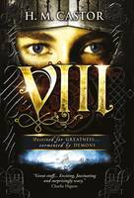
Destined for greatness - tormented by demons. VIII (Eight) is the untold story of Henry VIII, a gripping examination of why he turned from a charismatic teenager to the cruel tyrant he became in later life. Hal is a young, handsome and gifted warrior, who believes he has been divinely chosen to lead his people. But throughout his life, he is haunted by a ghostly apparition, and, once he rises to power, he turns to murder and rapacious cruelty.

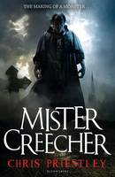
Friendship, trust and betrayal combine to form a dangerous liaison in this moving and frightening new book from Chris Priestley. Billy is a street urchin, pickpocket and petty thief. Mister Creecher is a monstrous giant of a man who terrifies all he meets. Their relationship begins as pure convenience. But a bond swiftly develops between these two misfits as their bloody journey takes them ever northwards on the trail of their target ...Victor Frankenstein. `A dark, moving, creepy, funny tale about the making of a famous monster...only not the one you think it'll be. Splendid gothic stuff.'

Award-winning Alan Gibbons pulls no punches in this moving contemporary story of lives torn apart by the divisions within our society. As boys, Chris and Imran are best friends and even blood brothers. Their love of football, family, friends and even school unites them; together they stand against all comers. As teenagers, they are sworn enemies; with Chris in the army and Imran newly politicised as a Muslim radical prepared to die for the cause. Told in different voices, their two stories are brilliantly interwoven creating a gripping, disturbing and thought provoking story of our time.
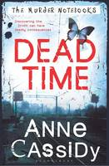
Award-winning Anne Cassidy grips her readers in this thrilling crime novel. Everywhere she turns, Rose’s life seems to be haunted by disaster. Her mother has been missing for five years after mysteriously vanishing with her partner. Now, following a new start at a new college, two murders take place and Rose is right there when they happen. Reunited with Joshua, her almost step-brother, Rose sets out to solve all the mysteries. It’s a thrilling unravelling with some clever twists.
14 year +

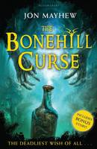
Arabian Nights meets 'Indiana Jones' (with a dash of Dickens). A superlative adventure packed with vengeful Djinni, flying carpets and a breathtaking race against time.Anthony Bonehill plans to outwit a Djinn with his seven accomplices. Six will make their wish and the seventh must wish the Djinn dead. But the seventh accomplice, Carlos Grossford, double-crosses them and now he can wield whatever tyranny he choosesNecessity Bonehill is a tomboy. Being sent to a boarding school for girls has honed rather than tamed her wild side. She fears her parents were keen to get rid of her, and therefore feels abandoned. So when Uncle Carlos starts sending her food parcels, she is happy that someone cares. Then one day he sends a stoppered bottle. Ness is perplexed, but surely there can't be any harm in opening an empty bottle? She takes out the stopper and unwittingly launches herself into and exotic and cut-throat world as the powerful Djinn is set free, hell-bent on revenge.

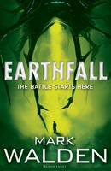
If you are caught you will not return, if you escape they will hunt you down. The enslavement of the human race has begun.
Sam wakes to see strange vessels gathered in the skies around London. As he stares up, people stream past, walking silently towards the enormous ships which emit a persistent noise. Only Sam seems immune to the signal. Six months later, Sam is absolutely alone. In his underground bunker he has food and water for a couple of days. He has no choice but to venture above. Spotted by a flying drone, Sam escapes, but not before the drone slashes him with a barbed tendril. That night, drenched in sweat, Sam realises without medical supplies the wound will kill him. This time above ground he is less lucky. Cornered again, Sam thinks he has reached the end - then the drone is shot down in a hail of machine gun fire. In five minutes Sam learns two things: he is not alone; the drone injury should have killed him instantly - yet he is still alive. The battle for earth is about to begin.

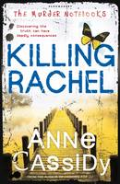
Rose's mother and Joshua's father have disappeared. Police inquiries have gone nowhere and the case, it seems, is closed: Rose and Joshua have been told that the police believe their parents are dead. But Rose and Joshua still hold out hope that they are alive. Joshua is determined to follow up his own inquiries, which includes working out the meaning of the cryptic notebooks - the murder notebooks - they have discovered. Then Rose is distracted by odd, desperate messages she receives from Rachel, a former best friend from her school, followed by the terrible news that Rachel is dead. But perhaps Rachel's death will provide one more piece of the puzzle about what has happened to Rose and Joshua's parents ...A taut and pacy thriller in The Murder Notebooks series, from an acclaimed writer for teens.
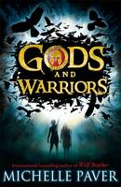
Hylas couldn't take it in. Last night he and Issi had made a camp in a cave. Now his sister was missing, his dog was dead, and he was running for his life. The Black Warriors - nightmares of black rawhide armour and bronze spears - want him dead. He doesn't know why, but their pursuit will be relentless. So begins his quest across land and sea with only Pirra, the rebellious daughter of a High Priestess, and a dolphin called Spirit for company. By the best-selling author of Wolf Brother, Gods and Warriors is this year's most hotly anticipated children's novel. The first book in a breathtaking adventure series set in the Greek Bronze Age: a time when the lowliest goatherd could rise to become a hero.
Best-selling teen author Sophie McKenzie hooks readers straight into this action-packed and page-turning story. A sequel to Girl, Missing and Sister, Missing this also works well on its own as Madison, shocked by news about her father, tracks down her ‘real’ father and finds herself caught up in a sleezy world of missing girls, babies and secret hideouts. Madison takes terrifying risks as she bravely searches out the truth.
14 years +

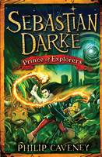
Deep in the remote heart of the jungles of Mendip, Sebastian, Max and Cornelius are in search of a legendary lost city. On route, they encounter the Jilith, a race of warriors locked in a deadly struggle with their mortal enemies, the fierce and brutal Gograth. Can Cornelius train the Jilith to defeat their enemies? Why does jungle girl, Keera think she knows Sebastian? Can Max avoid being turned into spare ribs? And, if they ever find the Lost City, can the three friends survive the ravages of the Night Runners - terrifying creatures that are already dead ...?

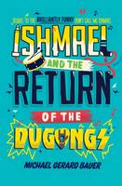
Ishmael is back at St Daniel's for another year of misadventure, with his best mate Razz determined to set him up with dream-girl, Kelly. But before Ishmael can win her heart, he has to overcome a mortifying pool incident, a nasty knock-out and getting caught red-handed with Kelly's diary. Ishmael's only hope lies with his Dad's rock band, but can the Dugongs set everything right?
This is a great read with a comic genius at work. It's the hilarious follow-up to the critically acclaimed Don't Call Me Ishmael! It deals with growing-up issues in an amusing way: school-life, friendship and bullying, written by an award winning Australian author. Readers will be instantly engaged with this moving, comic tale and the dialogue which is full of wit will draw you into the characters.
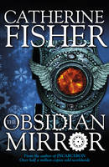
Jake's father disappears while working on mysterious experiments with the obsessive, reclusive Oberon Venn. Jake is convinced Venn has murdered him. But the truth he finds at the snow-bound Wintercombe Abbey is far stranger ...The experiments concerned a black mirror, which is a portal to both the past and the future. Venn is not alone in wanting to use its powers. Strangers begin gathering in and around Venn's estate: Sarah - a runaway, who appears out of nowhere and is clearly not what she says, Maskelyne - who claims the mirror was stolen from him in some past century. There are others, a product of the mirror's power to twist time. And a tribe of elemental beings surround this isolated estate, fey, cold, untrustworthy, and filled with hate for humans. But of them all, Jake is hell-bent on using the mirror to get to the truth. Whatever the cost, he must learn what really happened to his father.

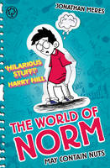
The everyday becomes ridiculous in this hilarious story of Norm’s life – as seen through his own unusual and somewhat biased eyes! Norm’s life seems to have gone badly wrong and it is all his parents’ fault. Why did they decide to move? How Norm gets through the ups and many downs of his life is a rollercoaster of laughs.
Norman knew it was going to be one of those days when he woke up and found himself about to pee in his dad's wardrobe... Why on earth did Norm's family have to move, anyway? In their old house he'd never tried to pee in anything other than a toilet. And when Norm is in bed, he's kept awake by his dad snoring like a constipated rhinoceros! Will life ever get less unfair for Norm?

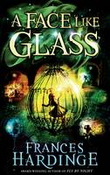
In the underground city of Caverna the world's most skilled craftsmen toil in the darkness to create delicacies beyond compare - wines that can remove memories, cheeses that can make you hallucinate and perfumes that convince you to trust the wearer, even as they slit your throat. The people of Caverna are more ordinary, but for one thing: their faces are as blank as untouched snow. Expressions must be learned, and only the famous Facesmiths can teach a person to show (or fake) joy, despair or fear - at a price. Into this dark and distrustful world comes Neverfell, a little girl with no memory of her past and a face so terrifying to those around her that she must wear a mask at all times. For Neverfell's emotions are as obvious on her face as those of the most skilled Facesmiths, though entirely genuine. And that makes her very dangerous indeed ...

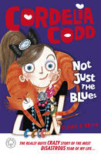
One day, I, Cordelia Codd, will be glamorous. I will take taxis everywhere, have an absurd-looking little dog, and Wednesdays will be manicure day. But for now, I'm stuck with: a totally un-glamorous school bus chauffeur, two mean EX-best friends, a 50% reduction in parents, and cat litter Fridays. Did I tell you how utterly ridiculous my life is...?
Ideal for fans of Jacqueline Wilson... the book is written with a real insight into the feelings of pre-teen girls, with all the emotions vividly described.

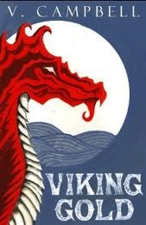
Sixteen-year old Redknee never knew his father. Now his uncle is Jarl and wants Redknee to be a great Viking warrior. But Redknee is clumsy, and more interested in tracking the wild deer of the forest. When the young Viking stumbles upon a war-party making for his home, he must grow up quickly; the brutal Ragnar burns the village, taking for spoils only a mysterious book. Along with a small band of survivors, Redknee takes to the seas. Braving fearsome storms and volcanic islands, bloodthirsty foes and strange new civilizations, the Vikings soon find themselves far beyond the reckoning of their people. But why would Ragnar kill so many for a mere book? Will its tales of faraway lands and riches lead Redknee astray? Or does the book hold the key to his past ...and his future? V. Campbells' debut novel is a thrilling tale of action and adventure, of love and loss, and the power of an unlikely friendship; join Redknee as he seeks out his destiny on the shores of the Promised Land

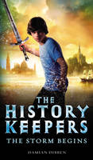
Imagine if you lost your parents - not just in place, but in time. Jake Djones' mum and dad have gone missing and they could be anywhere in the world - at any time in history. Because the Djones family have an astonishing secret, which for years they've managed to keep - even from each other. They belong to the History Keepers: a secret society which travels through the centuries to prevent evil enemies from meddling with History itself. In the quest to find his parents, Jake is whisked from 21st Century London to 19th century France, the headquarters of the mysterious History Keepers, where he discovers the truth about his family's disappearance - and the diabolical Prince Zeldt's plan to destroy the world as we know it...

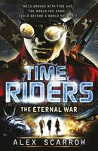
Liam O'Connor should have died at sea in 1912. Maddy Carter should have died on a plane in 2010. Sal Vikram should have died in a fire in 2026. But all three have been given a second chance - to work for an agency that no one knows exists. Its purpose: to prevent time travel destroying history...
A time wave has struck that alters the entire history of the American Civil War. Abraham Lincoln has followed Liam into the present from 1831 - and now the world is in a dangerous state of limbo ...If the TimeRiders can't return Lincoln to the past, the Civil War will never end. Can Maddy persuade two colonels on either side of no man's land to cease fire long enough to save the future?
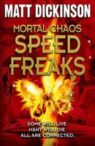
One beat of a butterfly's wings is all it takes to set in motion a chain of events, over the course of one day, which will change people's lives - and end people's lives. From the father and son diving in Hawaii to the teenagers surfing the bullet train...from the kidnapped girl in Rio to a bear attack in Japan...the chaos knows no bounds. The action is non-stop in this tense and compelling adventure.

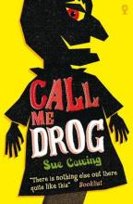
Parker’s got a lot of demons to face as he struggles to come to terms with his parent’s separation and his father’s expectations of him. He thinks he’s coping alright until he finds Drog in the dump. An ugly hand puppet, once on, Drog refuses to come off and he has a lot of things to say for himself – and for Parker. Goaded by Drog, Parker faces up to his fears in this moving coming of age story. Compelling, courageous and unforgettable, Call Me Drog is a classic coming-of-age story that packs a strong emotional punch.

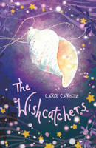
Antonia is sick of being bullied by Rosie, a mean girl at school. So when new girl Clarissa joins the school, Ant wishes Rosie would pick on her instead. But in Ant's seaside village they have a special way of making wishes: children write down their wish, put it in a lobster creel and row it out to Wishcatchers Point. Any wishes that disappear really do come true. But is it just coincidence or do the Wishcatchers really exist? When Rosie starts to bully Clarissa, Ant realises her mistake and tries to help. Perhaps if they can find out why Rosie is such a bully, and make her wishes come true, they can all become friends. And will the strange shell necklace that Ant has found help them to finally uncover the mystery of the Wishcatchers? This is a wonderful story of friendship and magic that will enchant its readers.

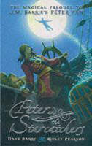
Discover the origins of Peter Pan in this swashbuckling tale, full of black and white illustrations! When Peter, along with his fellow orphans, boards the Never Land, it is only the start of his adventures. Befriending Molly, he discovers a treasure chest of starstuff - the most magical substance ever known to man. Peter and Molly must stop it falling into the hands of a dastardly (but eerily familiar) pirate and his murderous crew. Shipwrecked, helped by mermaids, captured by savages and attacked by a giant crocodile - will they ever succeed?

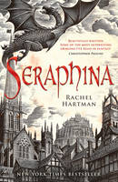
Shortlisted for the Waterstones Children's Book Prize 2013 The kingdom of Goredd is populated by humans and by dragons who fold themselves into a human form. Though they live alongside each other, the peace between them is uneasy. But when a member of the royal family is murdered, and is seriously threatened...
Into this comes Seraphina, a gifted musician who joins the royal court as the assistant to the court composer. She is soon drawn into the murder investigation and, as she uncovers hints of a sinister plot to destroy the peace in Goredd for good, finds herself caught desperately in the middle of the tension. For Seraphina hides a secret - the secret behind her musical gift - and if she is found out, her life is in serious danger...

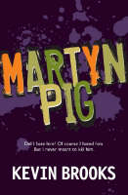
Award-winning novelist Kevin Brooks made his mark with this, his debut novel. A black comedy is something of a rarity in children’s books but here Kevin Brooks shows how it can be done. Martyn hates his father – and he has good reasons to do so – but he never meant to kill him. And maybe he didn’t anyway. But there’s a body to be got rid off and a story to tell. Martyn finds keeping up the stories gets more and more difficult as the lies get crazier. Martyn’s pessimistic view of the world takes a darker turn but there’s a kind of mad humour to it, too.
Did I hate him? Of course I hated him. But I never meant to kill him. With his father dead, Martyn has a choice. Tell the police what happened - and be suspected of murder. Or get rid of the body and get on with the rest of his life. Simple, right? Not quite. One story leads to another. Secrets and lies become darker and crazier. And Martyn is faced with twists and turns that leave him reeling. Life is never easy. But death is even harder.
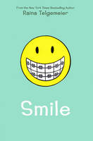
A graphic novel
Raina just wanted to be a normal girl, but one night after Girl Scouts she trips and falls severely injuring her two front teeth. What follows is a long and frustrating journey with on-again, off-again braces, surgery, embarrassing headgear and even a retainer with fake teeth attached. And on top of all that, there's still more to deal with: a major earthquake, boy confusion and friends who turn out to not be so friendly.

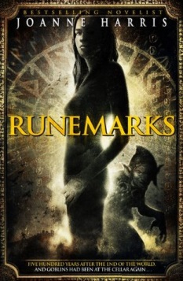
Maddy Smith was born with a rusty-coloured runemark on her hand - a symbol of the old gods and definitely cause for suspicion. For magic is dangerous. Or so everyone thinks. But Maddy enjoys working magic. Even if it is just to control some pesky goblins. Full of old magic and rich in atmosphere, Runemarks takes readers into the heart of Norse mythology. Born with a rusty coloured rune on her hand, Maddy Smith has always known that she has the gift of magic. While many pity her for it as it makes her an outsider, she loves the special qualities it gives her. But it has its dangers too. Maddy’s adventures lead her on a fantasy adventure full of magic and trickery into the World Below and the search for the relic of the old gods. Joanne Harris cleverly weaves new life and a feisty contemporary heroine into the familiar strands of old myth and magic.

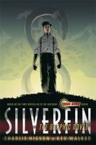
Young Bond : Silverfin The Graphic Novel by Charlie Higson
It's James Bond's first day at Eton, and already he's met his first enemy. This is the start of an adventure that will take him from the school playing fields to the remote shores of Loch Silverfin and a terrifying discovery that threatens to unleash a new breed of warfare.

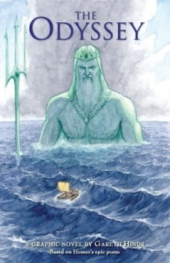
Gareth Hinds brings THE ODYSSEY to life in a masterful blend of art and storytelling. Vivid and exciting, this graphic novel is a worthy new interpretation of Homer’s epic."
Fresh from his triumphs in the Trojan War, Odysseus, King of Ithaca, wants nothing more than to return home to his family. Instead, he offends the sea god, Poseidon, who dooms him to years of shipwreck and wandering. Battling man-eating monsters, violent storms, and the supernatural seductions of sirens and sorceresses, Odysseus will need all his strength and cunning—and a little help from Mount Olympus—to make his way home and seize his kingdom from the schemers who seek to wed his queen and usurp his throne. Award-winning graphic artist Gareth Hinds masterfully reinterprets a story of heroism, adventure, and high action that has been told and retold for more than 2,500 years—though never quite like this.

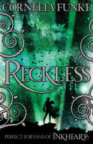
Best-selling author Cornelia Funke, whose Inkheart was a world-wide phenomenon, has created a wonderful new imaginary world peopled with a gigantic cast of original and outlandish characters. Searching for his missing father, Jacob Reckless steps through the mirror into a strange, story-filled world in which danger is never very far away. When Jacob mistakenly allows his brother to follow him through the mirror he discovers the awesome powers he is working against and needs to use all his skill and cunning to save his brother from a horrible death as he is gradually turned to stone. Cornelia Funke’s original storytelling captures the hearts and minds of all young readers.

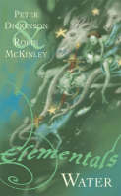
This is the first of four books of short stories from husband and wife team Peter Dickinson and Robin McKinley. Each book reflects and explores the magical and symbolic characteristics of the elements water, fire, air and earth, and contain stories from each author. The tales from the first book include stories of mermaids and underwater cities, celebrating the wondrous power and unknown territory of water.

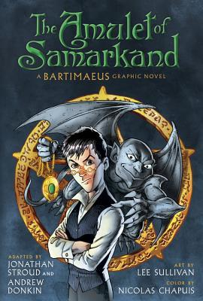
A modern-day London run by magicians. A stolen amulet. A tale of intrigue, murder, and revenge.
Nathaniel, an eleven-year-old magician-in-training, thinks he's ready to take on more challenging spells. With revenge against the proud and ambitious Simon Lovelace on his mind, he masters one of the toughest spells of all and summons Bartimaeus, a 5000-year-old djinni, to assist him.
But summoning a djinni and controlling him are two different things entirely. When Nathaniel sends Bartimaeus to steal Lovelace's greatest treasure, the Amulet of Samarkand, he finds himself caught in a whirlwind of espionage, murder, and rebellion.
Jonathan Stroud, along with acclaimed comic books-writer Andrew Donkin and artists Lee Sullivan and Nicolas Chapuis, turns the beloved and internationally best-selling first book in the Bartimaeus trilogy into a spellbinding graphic novel sure to excite and delight fans across all magical planes.

